**SPOTLIGHT CLEANING SERVICE INC.**

**Kelvin & Amy Stevenson**

**3800 Village Drive**

**Hazel Crest, IL 60429**

**Tel: 847-372-1229**

**Cell: 773-905-9061**

**Fax: 708-991-2765**

[**spotlightcleaningservice@gmail.com**](mailto:spotlightcleaningservice@gmail.com)



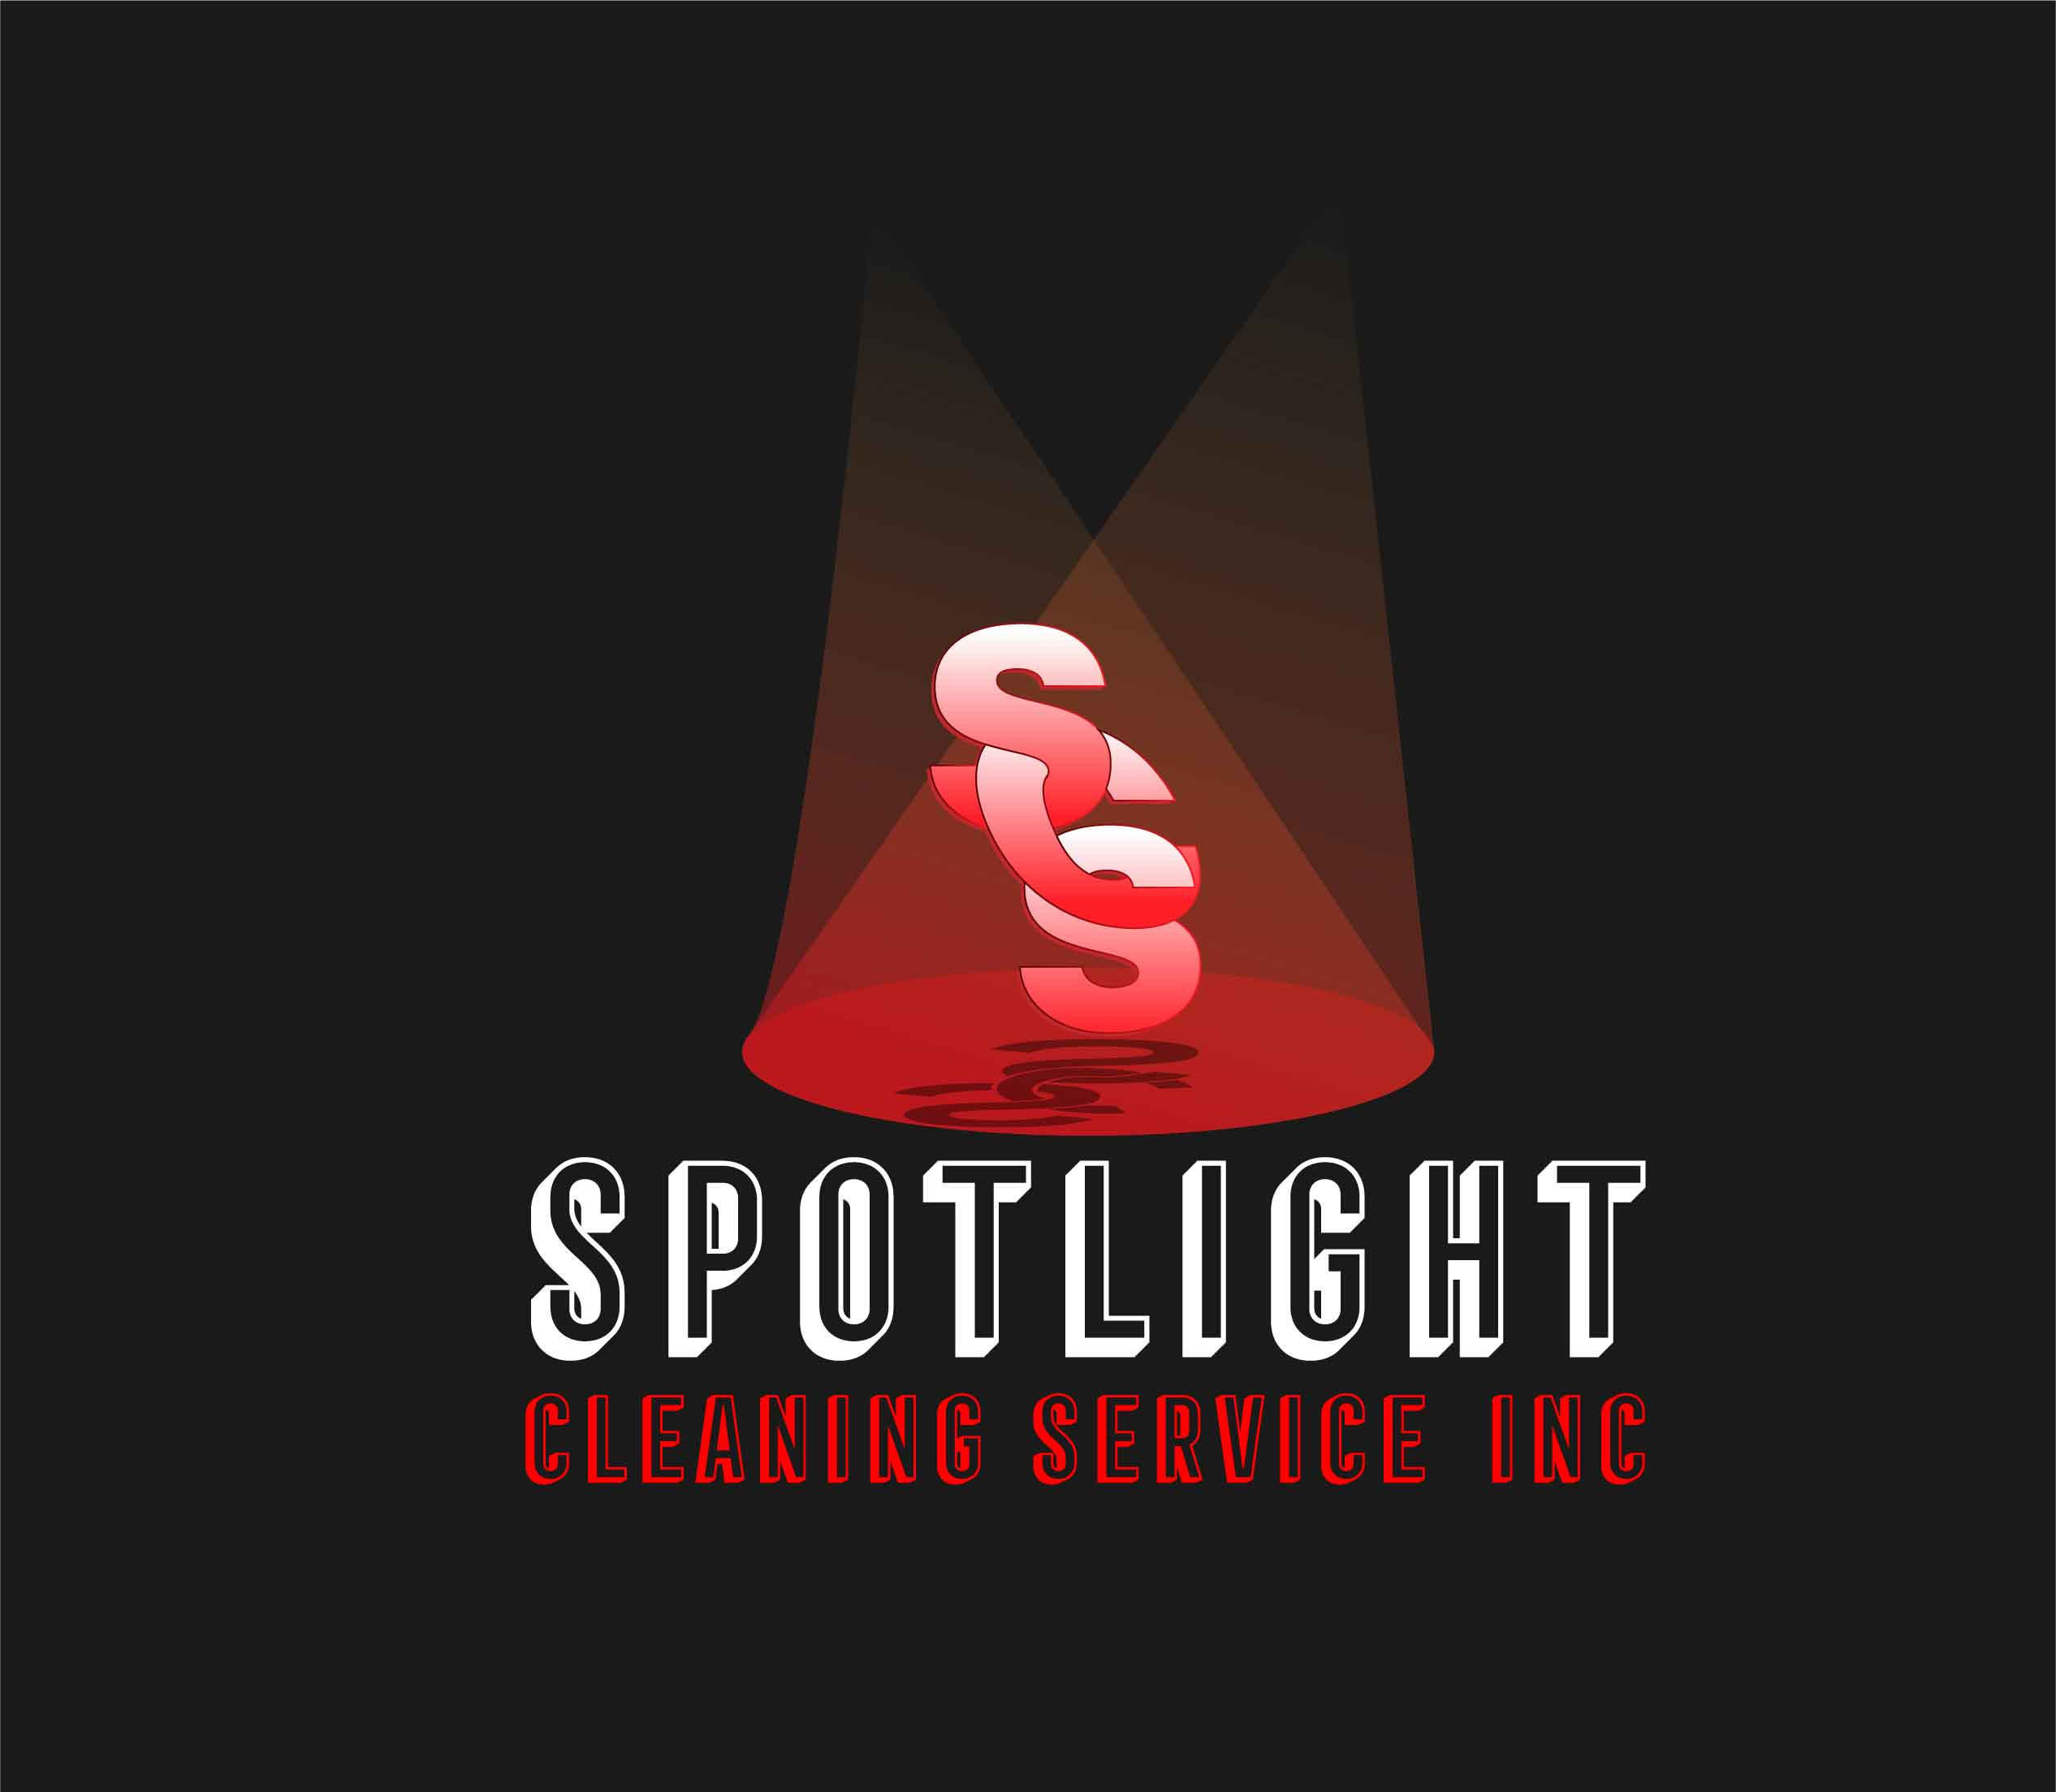

COMPANY DAta

* **Insured and Licensed**
* **MBE/DBE/BEP Certified**
* **NAICS CODES:**

**561720 -Janitorial**

**238990- Final Cleaning**

**561740- Carpet Cleaning**

* **CAGE CODE**

**9Z7T6**

* **Unique ID:**

**W2PZLAMUSP78**

**CAPABILITY STATEMENT**

# business summary

**Spotlight Cleaning Service Inc. is a trusted provider of high-quality janitorial, carpet cleaning, and floor care services. Committed to excellence, we deliver customized cleaning solutions with integrity, reliability and attention to detail. Our team ensures clean, safe, and well-maintained environments for commercial and industrial clients.**

# CORE services

• **Janitorial Cleaning**

**• Post Construction Cleaning**

**• Carpet Cleaning**

**• Floor Care-Stripping, Waxing & Buffing**

**• Ice & Snow Control**

**• Commercial & Residential Move In/Move Out**

# differentiators

**• Long-term client relationships are built on quality.**

**• Tailored services to meet unique client needs.**

**• Deliver on-time possession of properties.**

**• Clients trust us for consistent and dependable service.**

# current customers

• **Menards (Crestwood, Homewood, Schererville)**

**• Country Club Hills Village Hall- Office Cleaning**

**• Jesse Brown VA Medical Center - Final Cleaning**

**• Obama Presidential Center- Janitorial Cleaning**

**• Sutton Ford Car Dealership - Office Cleaning**

**• Wind Creek Southland Casino - Kitchen Cleaning**

**• ComEd Substations - Daily Office Cleaning**

# Past customers

• **Congressman Bobby Rush Headquarters**

**• Illinois National Guard Armory**

**• LA-CO Industries**

**• Shapiro Development Center**