SPOTLIGHT CLEANING SERVICE INC.
Kelvin & Amy Stevenson
3800 Village Drive
Hazel Crest, IL 60429
Tel: 847-372-1229
Cell: 773-905-9061
Fax: 708-991-2765
spotlightcleaningservice@gmail.com
www.spotlightcleaningservice.com
  - 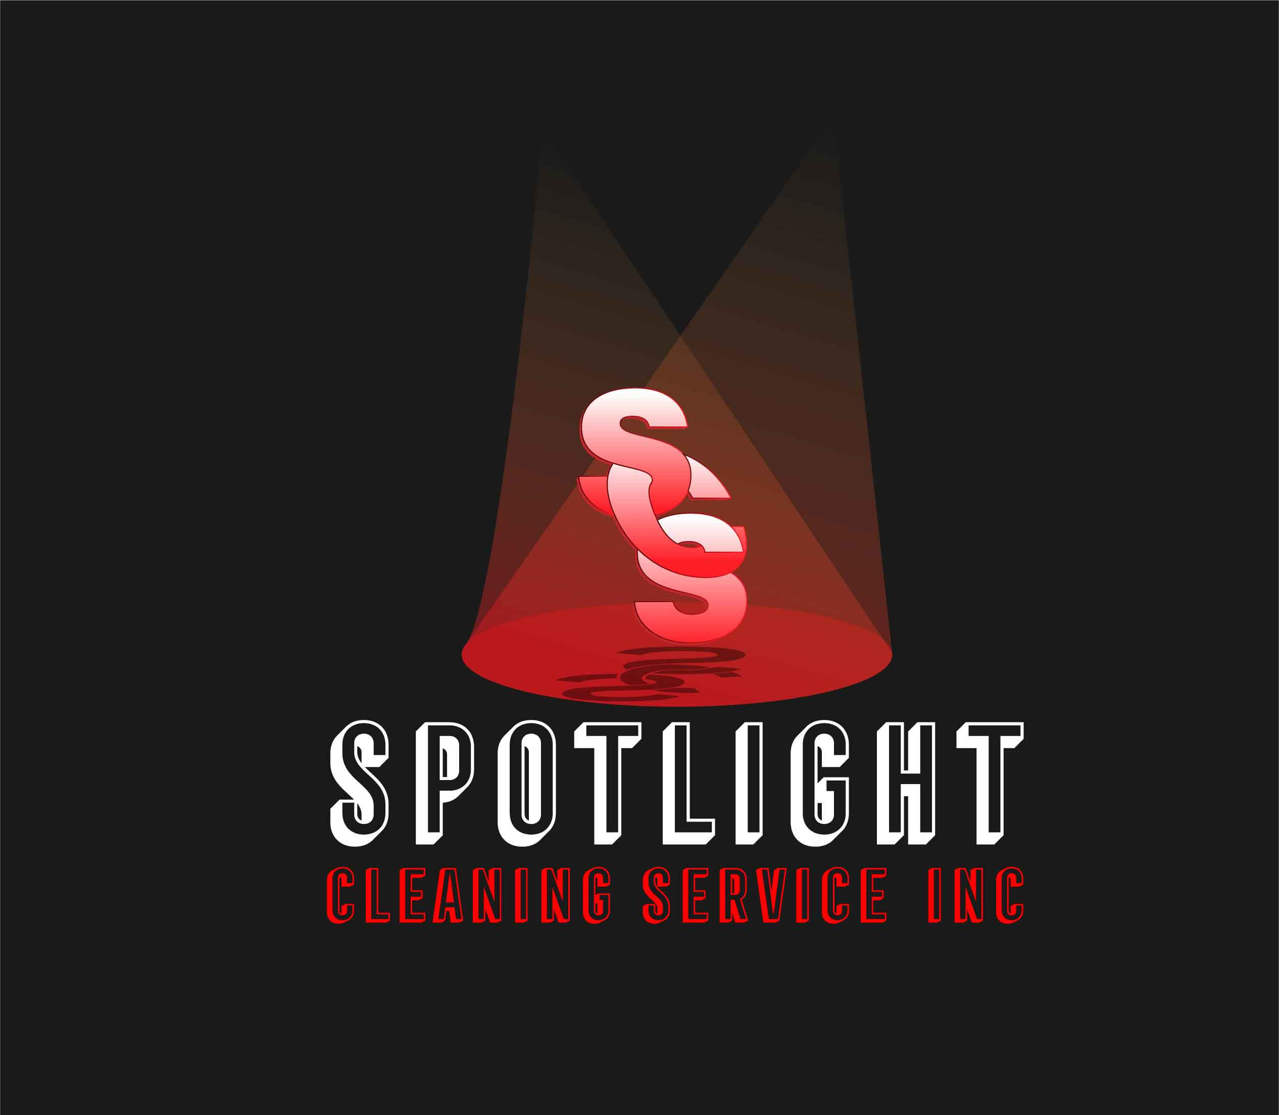
  - COMPANY DAta
- Insured and Licensed

- MBE/DBE/BEP Certified

- SBSP

- NAICS CODES:
238990, 561720,
561740,561790

- CAGE CODE
6G2j4

- DUNS NUMBER:
967785150

CAPABILITY STATEMENT

business summary
Spotlight Cleaning Service Inc. is a full line janitorial, carpet cleaning and floor care company. We pledge to meet the needs of our customers through a high level of integrity and providing quality and dependable services.

services
• Post Construction Cleaning
• Janitorial Cleaning
• Carpet Cleaning
• Floor Care
• Ice & Snow Control

differentiators
• Maintained over 85% retention rate.
• Offer customized cleaning plans.
• Deliver on-time possession of properties.
• Customers have a peace of mind.

current customers
• Menards (Crestwood, Hammond, Schereville)
• Congressman Bobby Rush’s Office
• Spoke & Bird Restaurant
• Lakeside Alliance Resource Center
• Altgeld Manors (CHA housing)
• Livewire Construction
• Advantage Management Properties

Past customers
• ICE Theaters
• Draper & Kramer Inc.
• Chicago Apartment Finders

